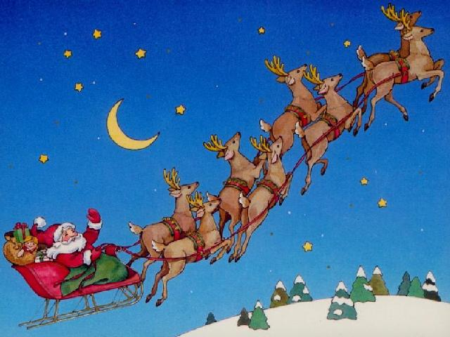
SANTA CLAUS PAIRS
SUNDAY 18th DECEMBER
1.30pm for prompt 2pm start
This is a Two Session Pairs Event.
Festive drink on arrival
The highlight between sessions is always our
SUMPTUOUS CHRISTMAS BUFFET
CASH PRIZES!
Coffee / Tea & Mince Pies during the prize giving…
….and everyone goes home with a gift!
Entry fee: £27.50 per PLAYER
Entries to Jeff Morris at Manchester Bridge Club,
30 Palatine Rd, Manchester M20 3JJ Tel: 0161 445 3712 e-mail: jeff@manchesterbridge.co.uk
LIMITED ENTRIES - PLEASE BOOK EARLY

