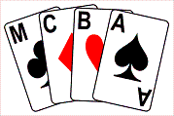

The Manchester Bridge Congress
Sat 7th and Sunday 8th January 2017
Pairs Championship Saturday 1pm – 10pm.
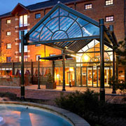
Teams Championship Sunday 11am – 7pm.

At The Manchester Marriot Victoria & Albert Hotel, Water Street, Manchester, M3 4JQ (Hotel reservations – 0161 832 1188)
Congress enquiries and entries to JEFF SMITH Tel. 0161 702 3773. Mob. 07976 794390. Email: jasmith@nildram.co.uk

