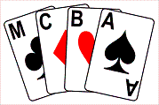
The Manchester Bridge Congress
Non-Expert Events Entry Form
The Players Progress Cup – Saturday 7th January 1pm to 5pm
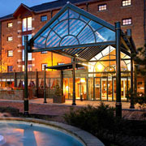
The Kevin Comrie Trophy – Sunday 8th January 1pm to 5pm

At The Manchester Marriot Victoria & Albert Hotel, Water Street, Manchester, M3 4JQ
As non-expert players you & partner can enter either or both of these events.
We wish to enter the Players Progress Cup on Saturday 7th January

My partners name is ________________________________________
We wish to enter the Kevin Comrie Trophy on Sunday 8th January

My partners name is ________________________________________
My name: ____________________________________________
Mobile No: (or landline if no mobile) ______________________________
Email: _______________________________________________________
The Entry Fee for each event is £16 per partnership.
Please post this entry form and a cheque to Susan Triggs, 5 Tumblewood Drive, Cheadle, SK8 1JZ and also email Susan at grasan30@gmail.com to confirm your entry. Cheques should be made out to MCBA.
“Good Luck & Have Fun!”

