NORTH WALES BRIDGE ASSOCIATION

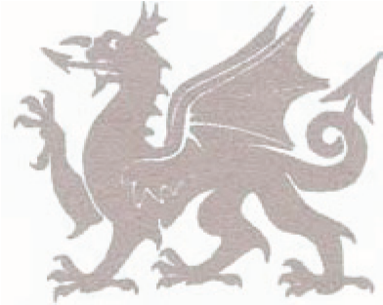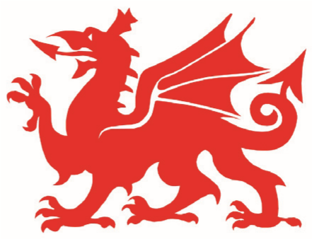

NWBA SWISS PAIRS*
GREEN POINT EVENT

Saturday 10th October 2020
On BBO
7 x 6 board matches
11.00am with a 1 hour break after match 4
£20 per pair
Pre-entry and pre-payment essential
To enter follow this link:
https://www.bridgeextra.com/nwsp/

*BBO Swiss Pairs scored and assigned by match points, rematches possible

