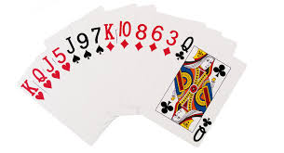
YOU’RE JUST A CLICK AWAY……….
…….. FROM LEARNING TO PLAY BRIDGE!!

- Our new Beginners Courses are just about to start in September and October and classes are available Face to Face, online or both.

- Classes are really easy to access and are small and personal with loads of help and a lot of fun.

- We can offer a range of sessions across Greater Manchester and you can learn either by yourself or with a friend.
- Details of all our teachers are listed below. Get in touch with the ones who you think will be most convenient for you.

“Bridge is a wonderful and exciting game – what better time to learn to play when winter looms?”

If you need further advice before contacting a teacher email Susan at grasan30@gmail.com to find out more.
MANCHESTER COUNTY BRIDGE ASSOCIATION

