LIVERPOOL BACKGAMMON CLUB presents
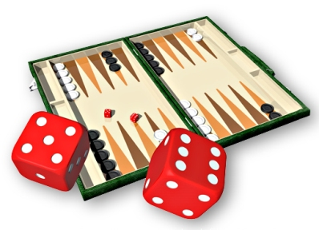
22nd LIVERPOOL OPEN
Sat/Sun 15th/16th July 2017

*** NEW VENUE for 2017 ***
Leo Casino, Liverpool Waterfront
44 Chaloner St, Liverpool L3 4DE

entry £50 (minimum £28 returned as cash prizes)
* includes free hot lunch on Saturday & Sunday
* free tea/coffee throughout * tote/ side pools * trophies
*** new for 2017 – Saturday evening Doubles ***

to register, email liverpoolbackgammon@yahoo.co.uk
(payment details will be given when you register)

club website: http://www.liverpoolbackgammon.co.uk/

TOURNAMENT SCHEDULE
SATURDAY | daytime | SUNDAY | daytime
REGISTRATION | 10:00-10:45 | Registration | 09:00-09:45
Draw | 10:55 | Draw | 09:50
START | 11:00 | START | 10:00
MAIN | 5 x 7pt matches | MAIN | Top 16 qualifiers
 | Swiss Format |  | 9pt/11pt knockout
 | 4 & 5 wins qualify | CONSOLATION | 7pt knockout
 | 3-win 1pt knockout | LAST CHANCE | 3pt knockout
1pt SHOOTOUT | min. first 2 rounds | 1pt SHOOTOUT | completes
FINISH | 6.30pm | FINISH | 6pm
SATURDAY | evening
DOUBLES | 8pm
 | £20/pair
 | 5pt knockout

