2nd MANCHESTER OPEN TOURNAMENT REPORT
10-12 November 2017

ROLL OF HONOUR
Event | Winner | Runner Up
Main (11 points) | Jon Wilkinson | George Hall
Consolation (7 points) | Steve Bibby | John Wright
Last Chance (5 points) | Fanika Petskovska | Ian Gray
Early Swiss leavers (5 points) | Steve Allott | Dave Pritchard
1 point shootout (1 point!) | Michael Levi | Mark Manley
Doubles (5 points) | Sarah Joliff/Vin Nolan | Dorothy Lee/Mate Féhér
Free roll (5 points) | Irving Czechowicz | Guy Haslam

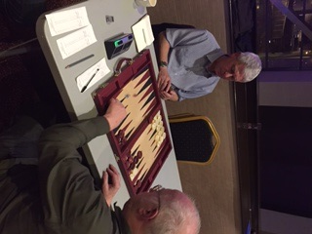
Manchester Open 2017 Finalists- Jon Wilkinson and George Hall
TOURNAMENT STATS
- 64 players attended
- 8 women and 56 men
- 27 from Manchester/Merseyside area, 6 from wider Lancashire, 14 from Yorkshire/North East, 7 from the Midlands, 6 from the South, 4 from overseas
2 cases were referred to the geographical location committee but regrettably its members could not be found. So, the organisers deemed Mate Féhér to be from overseas on the fairly spurious grounds that he lives in Budapest and nobody knows where Tony Smith lives so he has been put in the Yorkshire/North East pot.
- Excluding pool winners, 20 out of 64 (31%) left with cash prizes of minimum £40.
TOURNAMENT THANKS/ACCOLADES
Firstly, thanks to the staff at the Grosvenor Casino, Didsbury without whom we could not have had the tournament. The casino team made a special effort to open early on both days for no charge which was very much appreciated. They were very professional, approachable and helpful. Many people were also appreciative of the hot buffet on both days and continued servings of cold food through the day with tea and coffee. In particular, Richard Coburn who actually placed his board in the middle of the chilli con carne container and refused to move. The organisers however are unable to refund Kevin Jones who had brought in his own Fray Bentos pies, Arctic Roll and packets of lovehearts.
Secondly, the efforts of Mark Calderbank and Jamie Evans on both days as Tournament Directors were magnificent. They ran the front desk in not only an efficient and professional way but also by being extremely approachable and empathetic in their dealings with players and their accompanying highs, lows and occasional indifference. Thanks to their stewardship, the tournament generally ran well to time and this was borne out by the consolation finishing just before the main final with everything wrapped up around 8pm on Sunday as was scheduled. Insight and work behind the scenes was provided by Peter Snape with oversight and advice from Kevin Jones gratefully received.
The innovations introduced by Mark were extremely well received. In particular, showing the results of the Main Swiss as they came in and updating each player’s record on a big TV screen. At any time, all players could assess where they and the other players were all placed. From the play offs and last 16 on Sunday, results could be followed live. Additionally, an SMS text messaging service was introduced so players could be reminded through their mobiles that they had a match to play. This contributed to lack of blockages and matches being played to time.
Thirdly, thanks to the prize givers. There was a natural sense of disappointment when none of the main prize givers, Sergio “Kǔn” Aguero, Lorraine Kelly or the bloke who played Terry Duckworth could make it. However, we are very grateful to Brian Lever and Eric McAlpine two legends of UK backgammon for stepping into the breach and presenting the prizes. Your correspondent, having never been near a prize giving ceremony in his life, was given a short demonstration of protocol by Eric and both of them gave all the ceremonies the respect the occasions deserved.
SHUT UP AND TELL US WHAT HAPPENED
The tournament turned out to be memorable for three main characteristics aside from the number of very close and tight matches; the North West triumph, the march of first time UKBGF Tour trophy winners and an excellent degree of sporting behaviour and etiquette.
Players from the North West and indeed who play weekly and/or monthly at the local Manchester Heaton Moor Club essentially made all the finals. The only exceptions were Guy Haslam and Sarah Joliff, although both are in the North West Backgammon League. What? Even Dave Pritchard? Well yes. Indeed Dave and Rob Perry have been stalwart supporters of the monthly Manchester 11 point tournaments for years as well as those nearer home. Hopefully, they will be aware that their presence is always appreciated.
It was noticeable as to how many players won their first UKBGF Tour trophies, in amongst more seasoned Tour Trophy winners such as Steve Bibby and John Wright. Jon Wilkinson, George Hall, Fanika Petskovska Ian Gray, Sarah Joliff, Vin Nolan, Steve Allott, Irving Czechowicz all got their hands on their first trophies of the Tour. Hopefully, they will go on to win many more.
As a result of being hung by Ian Turner, drawn by Sean “Yes Sir, I can boogie” Jones and quartered by the inimitable Michael Levi in in the Swiss, it allowed your correspondent more time to observe what was going on. All tournaments have a good sense of sporting play and good humour since they are often composed of the same players but one feels it is worth mentioning in this report. There were very few minor disputes, little poor time management but a lot of good humour and a sense of proportion in both triumph and disappointment – all these things contributed to the tournament. There were instances of players’ encouraging and coaching others which was nice to see.
MAIN TOURNAMENT
We all know the epics don’t we, Ali vs Frasier, Borg vs McEnroe, Ovett vs Coe, Cowell/Osbourne v Daly/Winkleman etc and our final between Jon Wilkinson and George Hall deserved to be remembered in that same bracket. The final couple of games with George 10-9 ahead were quite simply stunning with both players holding their nerve whilst joker rolls were coming all over the place, Jon’s double 3 on a 5 point board when the epitaph writer was just composing his backgammon obituary, the 6-2 to hit from George as the metaphorical shark had almost his whole body in its jaws followed by the next roll off the bar of 2-6 from Jon and leaping out of the inferno to relative safety and the road to victory. Calderbank, McAlpine, Jones, Bibby et all were rendered speechless left only with the ability to half mouth incoherent whispers as if concussed from blows to the head. Through it all, like the true gentlemen they are, both Jon and George maintained their calm and respect for each other and the game.
Interestingly, both our finalists came though the 3 point play off brackets, another good idea enforced by Mark and Jamie. It led to some tense and interesting matches but ensured that these were less of a lottery than otherwise might have been to reach the last 16. The two semi finals both went down to the wire and were hard fought with Christian Cozos and Simon Jones unfortunately losing at the death. Other hard luck stories were Lee Gorton narrowly beaten by Christian and Keith Gill, another from the play offs was unlucky against George. Both Sarah Joliff and Ian Gray had good runs into the last 16. Richard Coburn had some misfortune in the Swiss but polished off the chili with aplomb.
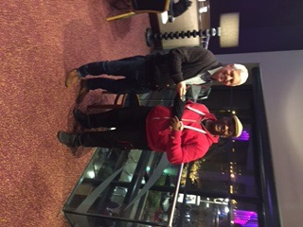
Jon Wilkinson receiving the Champion’s trophy
EARLY SWISS LEAVERS
Of course whilst many players march triumphantly on through the Swiss, with a 64 player tournament there will be a few who are unlucky enough to lose their first three games. Unashamedly stealing the idea from the Blackpool tournament vault of interesting formats, we held a free entry 8 player knockout tournament for these players with a £40 cash prize and voluntary pool. The event ended with a rousing final between Steve Allott and Dave Pritchard with Steve narrowly winning on the last roll. Regrettably, we do not have a picture of Steve but for those who do not know him he is tall, bespectacled, a touch of grey and the odd one or two may say relatively good looking. Frankly, the jury is still out on that one.
CONSOLATION
An excellent tournament saw Steve Bibby triumphant over John Wright in the final. Both had tight semi-final wins against Irving (I’m on fire) Czechowicz and Mate (the hokey cokey man – in the tournament, out of the tournament, in again, out again and in shaking it all about) Féhér respectively. One or two hard luck stories here also with Jon Barnes losing on a tense 4 cube to Irving and Anna Clarke narrowly losing an epic to Mate.
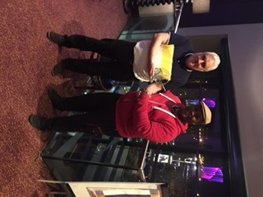
Steve Bibby – consolation winner
LAST CHANCE
Local club players Fanika Petskovska and Ian Gray played an exciting final with Fanika narrowly coming out on top in the DMP game. Both won their first UKBGF Tour trophies and Fanika, as Macedonia’s number one player, was able to add another victory to her collection. Ian must be amongst the most improved players in the country as his results are now showing how his game has come up leaps and bounds. Regrettably, lack of budget and, frankly, willingness, meant it was not possible to accede to Fanika’s demands for a) a UKBGF Banner as a backdrop for the trophy presentation b) a lectern and microphone for a valedictory speech c) the Strictly glitter ball trophy d) an invitation to the Graham Norton show – to showcase her new series, Friday night with Fanika.
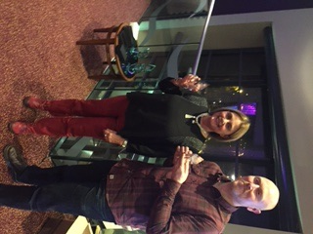

1 POINT SHOOTOUT
Michael Levi was the winner and can now rightly call himself the UK’s one point champion as this was his second Tour victory. Mark Manley was the unlucky runner up. Michael was able to swerve his way through the obstacle course of several good players on his route to the trophy, past Chris Derry, Samya Abdullah, Tiberiu Bostan and err…..your correspondent. We live in hope that Michael’s Jerry Lee Lewis tribute act will receive the acclaim it deserves – headphones on, tapping gently on his counters (Come on over baby…), increasing the rhythm of the tapping (whole lotta shaking going on) muttering “Come on Michael, any double now, come on Michael”, suddenly jumping to his feet furiously shaking the dice (shake, baby shake, come on Michael just one double), breathing more heavily, eyes wider (I ain’t faking…..Come on Michael), deep breathing, jumping up and down and then (whole lotta shaking, Come on Michael, double 6) launching his dice…..aarghhhhh a 2-1!!
Moving back to reality, Michael is an excellent player and adds much to tournaments.
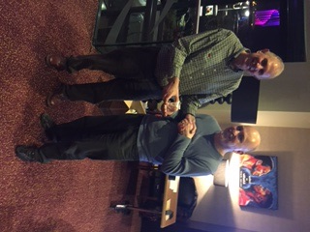
Michael Levi receiving his winner’s trophy
DOUBLES
We had consulting doubles on Saturday night. 6 teams entered and some backgammon did break out amongst the general mayhem of deciding which format to use, trying to find Jysen, Vinny losing his lager, Jamie canoodling, Ian and Frank bringing in a risk analyst to advise over a tricky 4-3, said risk analyst Jimmy Wong asleep on the blackjack table, Ana and Aysel playing cards on his back…….
Eventually, Dorothy and Mate on one side and Sarah and Vin on the other persevered through to the final played on Sunday. Closely fought but in the end the Sarah/Vin team came through and claimed their first UKBGF trophy as displayed below. Hopefully, they will enjoy more success but if not, they could easily audition for a new sitcom… the new Terry and June?
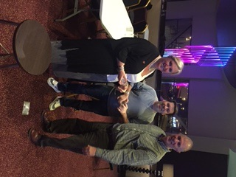
FREE ROLL
Grateful thanks to the nearly 30 players who turned up on Friday evening. Special thanks to Paul Thompson who, unknown to any of us possessed hidden feng shui talents and was a great help in arranging the room for the weekend. If you can imagine Kirsty Allsopp with pint of lager in each hand, fag in mouth then you get the picture. The event was won on the Saturday by Irving “Sheena is a punk rocker” Czechowicz who defeated a gallant Guy Haslam in the final.
Thanks to all who came this year. Next year will be bigger and better and hope to see everyone there.

