Manchester Backgammon Club
Tuesday Club Night Online at Backgammon Studio Heroes
(last updated 30th March 2020 by Peter Snape)

Join Backgammon Studio Heroes (it’s free!)

https://heroes.backgammonstudio.com/?register=1

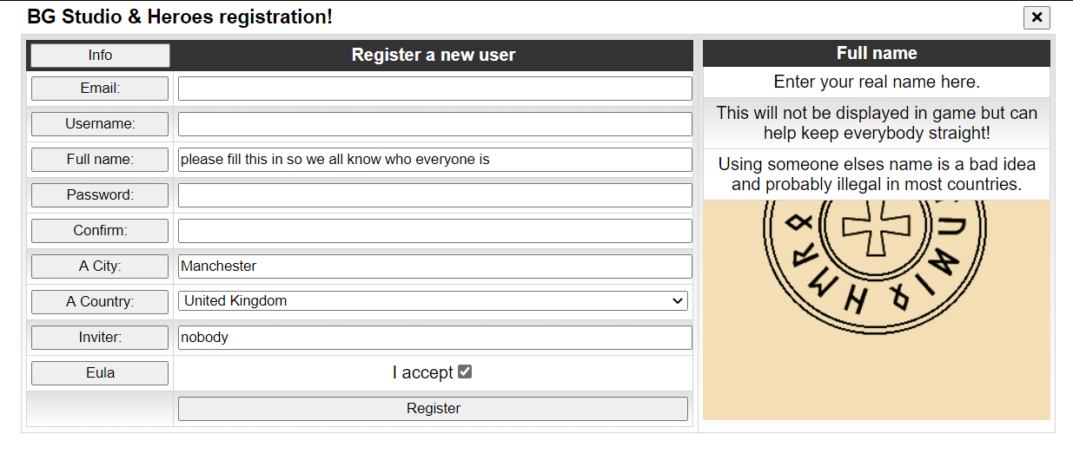

You’ll then get an email with a link to click to confirm your email address.

Play on Backgammon Studio Heroes

https://heroes.backgammonstudio.com/

You will see a list of players currently online:

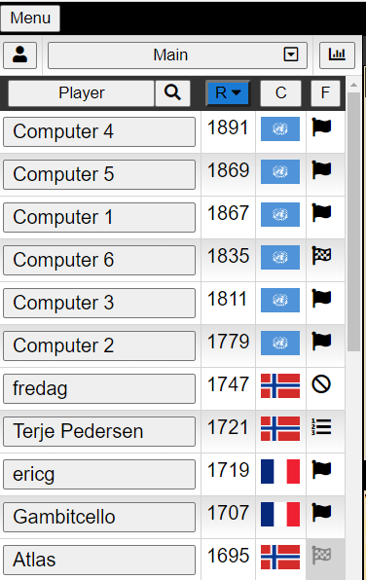

You can sort this by player name, rating, country or status by clicking the relevant column header:
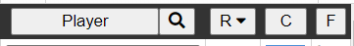

You can see just players from your own country or city by selecting from the “Main” dropdown box:
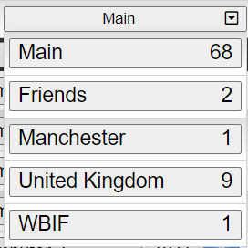

Set your status by clicking on the flag in the “F” column:
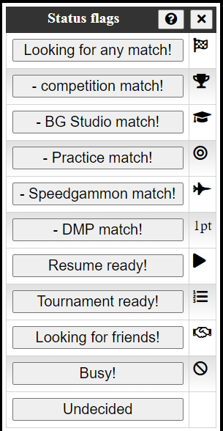

To invite someone to a match, click on their name and select match length, clock settings etc:
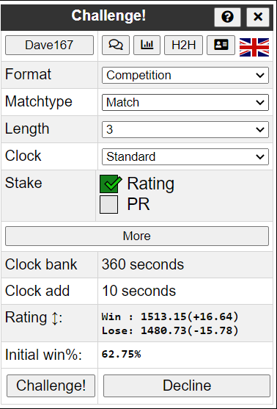

Playing in Tournaments

Before you can play in a tournament, you must first play at least 2 matches of the same length as the tournament will use. Manchester Tuesday club nights will be 5pt-ers so you’ll need to play two 5pt matches first.
Once you have done this, activate tournaments - click “Menu”:
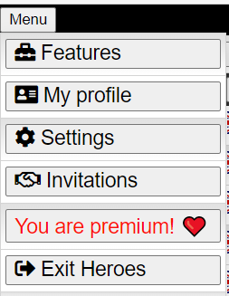

Then click “Features” and switch on “Tournaments”:

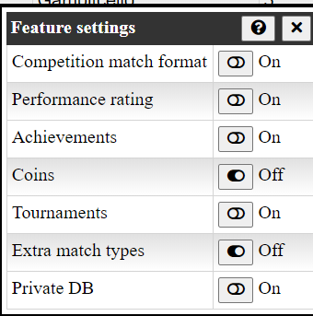

Now you should see tournaments appear in the top bar:

Click on it to see what tournaments are available:
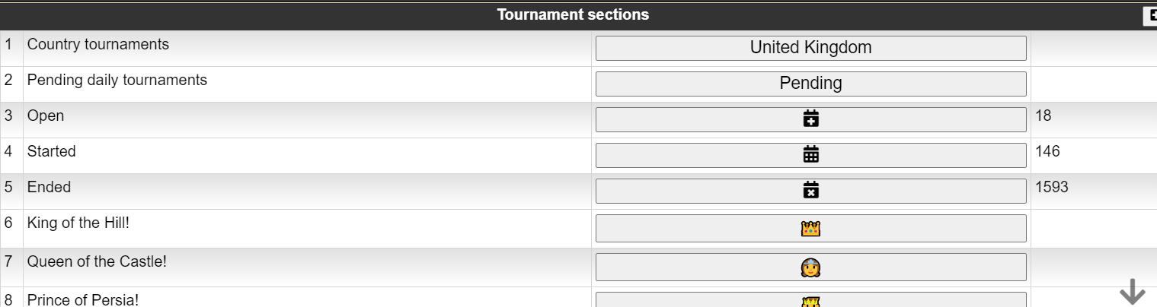

Manchester Tuesday club nights will be restricted to UK players so click “United Kingdom”:
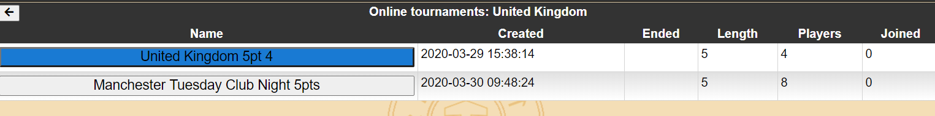

Click on “Manchester …..”
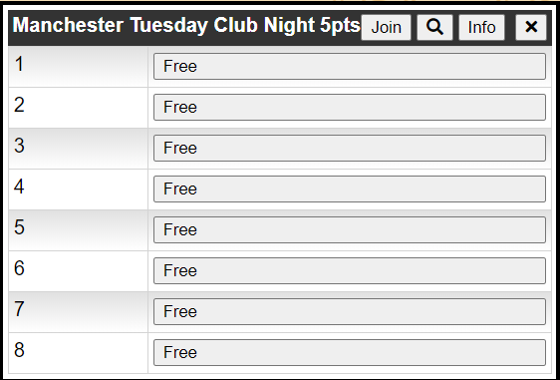

Click on “Info” to see the tournament format:

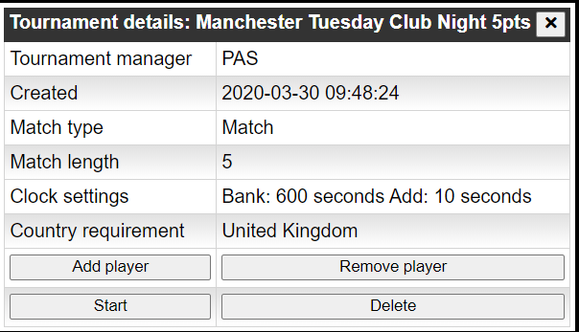

Click on “Join” to enter:
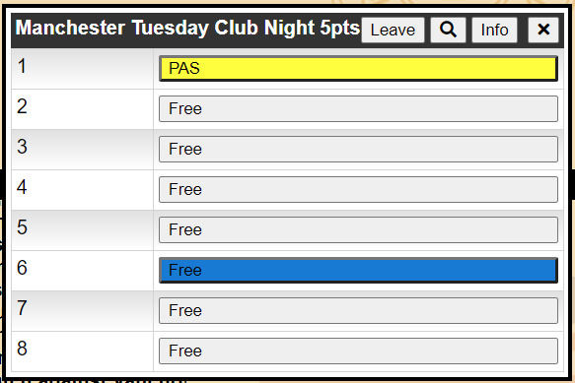

Click on “Leave” if you change your mind.
Note that you will lose your place if you log out, so no point entering too early.
I will start the tournament at 7:30pm on Tuesday (as long as it’s at least half-full), so be there by around 7:15pm to ensure you have enough time to enter.
Once it starts, you can see the draw by clicking on the tournament.
First named player for each match should invite second named (I don’t think it’s automated).
For any queries or corrections please contact me.
Hope to see you there next time.

